A birding trip in Albania: The Land of Eagles and Castles
(A three-day birding trip, plus: by Tom Cook)

Four times now I have visited the beautiful but little-known country of Albania. My first three visits were work based but I decided that, at 66 and retired, I would enjoy a holiday in a country I had come to love. Having been a ‘casual birdwatcher’ for most of my life I finally became a ‘birder’ when I relocated to my Tyneside roots in 2018. So why not a birding trip while on holiday?
A little research led me to the Facebook page of Shpendët e Shqipërisë (Birds of Albania) and a great guy named Mirjan Topi. One of very few ornithologists in the country and co-author of the first complete field guide of birds in Albania (also author of a very useful dictionary of bird names giving the Latin, English, French and Albanian names). To my surprise, and delight, Mirjan was to be my guide, driver, tour organiser and expert advisor for my three-day trip.
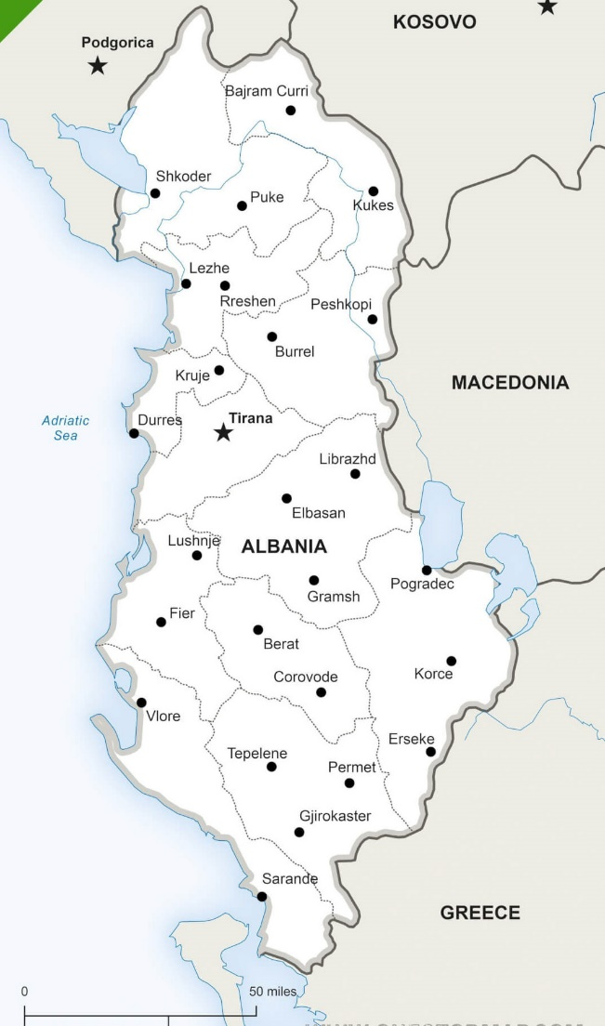
Most of my holiday was spent in and around the port and resort town of Durrës on the Adriatic coast. My birding trip was to take in the Laguna e Nartës (Narta lagoon) some 72 miles south. After an overnight in the nearby town of Vlorë on the coast we would then head inland into the Southern Mountains visiting, and staying near to, the lovely town of Gjirokaster about 65 miles to the south east. Obviously Mirjan also knew of some good birdwatching locations in the area.
Mirjan picked me up from my hotel at 8.30 on a quiet and sunny Sunday morning. ‘Quiet’ was good after the previous days 5.8 earthquake and three aftershocks (the last just after midnight). Durrës, just short of
4 miles from the epicentre, had suffered
structural damage but gladly no serious injuries to people. Yours truly was just a bit bleary eyed. Mirjan had been in the capital Tirana the night before where the story was similar.
Source: www.onestopmap.com

Laguna e Nartës
The Vjosa – Narta Protected Landscape covers an area of approximately 75 sq. miles and encompasses the Laguna e Nartës (Narta Lagoon) and the estuary of the Vjosa River, considered to be the last really wild ‘big’ river in Europe. The landscape is part of a large preserved ecosystem including various habitats of pine and riverine forests, freshwater wetlands, salt marshlands, shrubland and sandy dunes. Despite occupying a relatively small area the number of species recorded includes 1400 vascular plants, 32 mammals, 194 birds (as I started to write this account my friend Mirjan added the recently spotted Great White Pelican (Pelecanus onocrotalus) to the list), 26 reptiles, 9 amphibia, 90 fish and 390 invertebrates. The area hosts 26 globally threatened species and amongst the most notable wildlife are Greater Flamingo, Dalmatian Pelican, Golden Jackal and Dolphin (bottle nosed and short beaked are known to inhabit the coastal waters)
We entered the protected landscape on a rough access road sided by scrubland and the birds immediately began to show themselves.
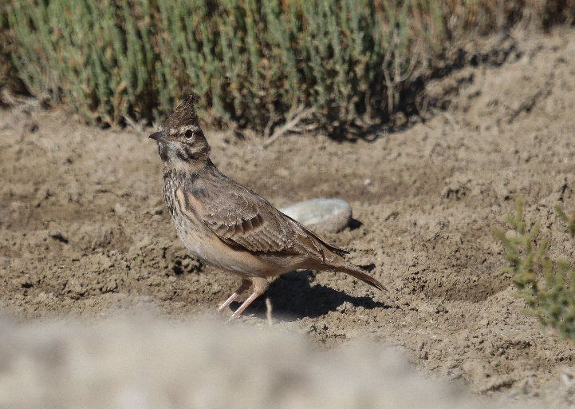
First up was a Crested Lark (Galerida cristata) just at the road edge but tucked into the shadow of a grassy tussock and not showing well at all. Very quickly two more appeared in the open, although keeping their distance from our very slow-moving vehicle.
So Mirjan stopped the car and in the next few minutes we managed a few photos and also had several Northern Wheatear (Oenanthe oenanthe) and a rather skittish Tawny Pipit (Anthus campestris) appear. Crested Lark
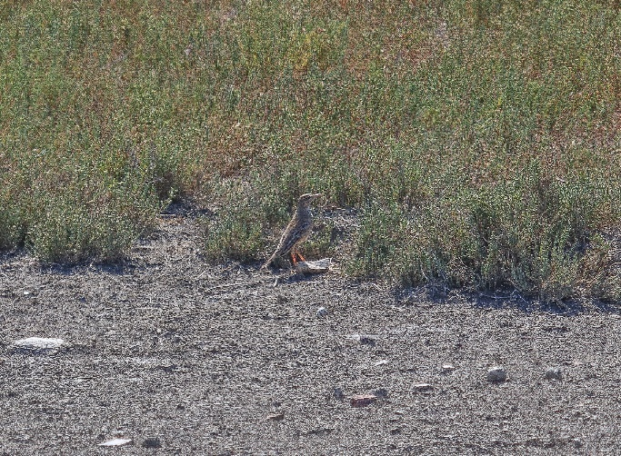
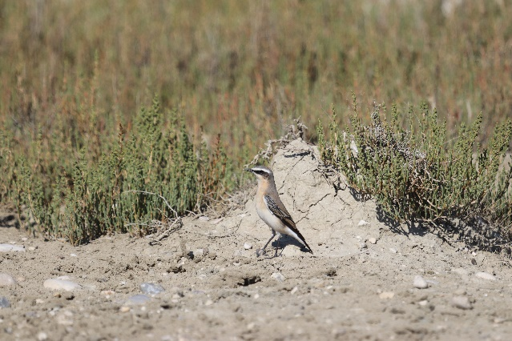
Northern Wheatear
Tawny Pipit
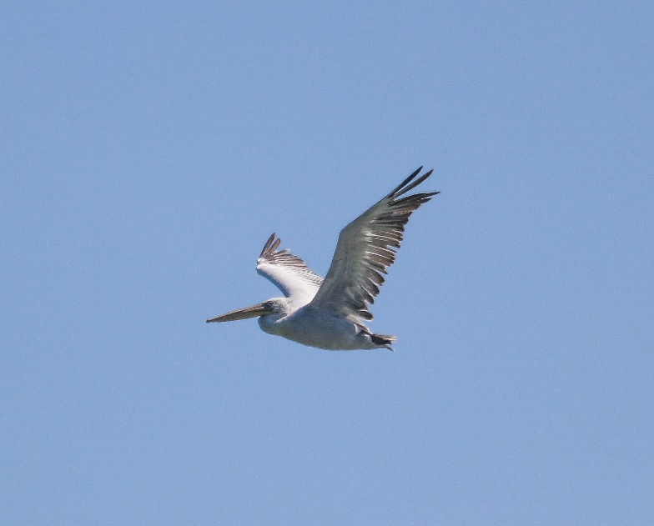
I had missed the Hooded Crow (Corvus corone cornix) seen just up the road from me in Whitley Bay earlier this year but several made an appearance over the next few minutes. I was to see many more over the next few days too. Just then, however, a bird I had wanted to see this trip announced itself as three Dalmatian Pelicans (Pelecanus crispus) flew over further ahead. The Dalmatian Pelican is one of the largest species with a wingspan of 270 – 320cm and stands 170 – 190cm high. It’s weight of up to 15kg makes it one of the heaviest flying species too. In Albania the only breeding site for this bird is the Divjakë – Karavasta National Park some 38 miles to the north of Narta. Mirjan, however, knew that we would more likely see the birds here at Narta. It is reckoned that in the 1960’s there were some 200 breeding pairs, down to 17 in 2000. While a recovery shows that 68 breeding pairs were recorded for 2019 the species is still classed as Critically Endangered in Albania and continuing pressure from developers continues to threaten the country’s wetland habitats. Dalmatian Pelican
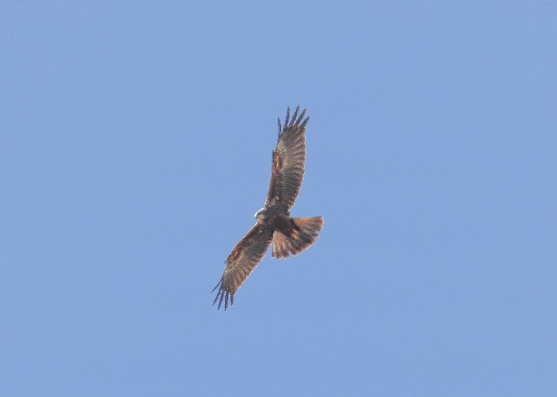
The Pelicans were just moving away when a juvenile, male, Western Marsh Harrier (Circus aeruginosus) appeared. Now I’ll be honest and admit that my ID skills are nowhere near good enough to allow me to give you that amount of detail and this wouldn’t be the last occasion that I relied on my expert guide. The bird was swirling high against a brilliant blue sky and strong sun so even a detailed view through the bins was proving difficult for this novice. I had seen just one pair of Marsh Harriers at East Chevington, earlier this year, but I probably saw ten individuals in the next three days. Western Marsh Harrier

We saw the first of a few small groups of Barn Swallow (Hirundo Rustica) that we would see over these three days. I was certain that I had previously seen Red-Rumped Swallow (Hirundo daurica), of all places, swooping over the hotel pool while I was having my daily swim! Small flocks of House Sparrows (Passer domesticus) would also appear regularly with small groups of Starlings (Sturnus vulgaris) showing occasionally.
Then it was on to the lagoon itself. Mirjan explained that there would be very few birds on the actual lagoon. They would instead be in the Salinas next to the lagoon. The two are separated by a high, road topped embankment. What I though was a very large white building on the far side was actually a mountain of salt. The road was just wide enough for two cars to pass. Two birding towers had been erected on the lagoon side of the road. Mirjan’s prediction was again accurate as you can see from the photographs below.

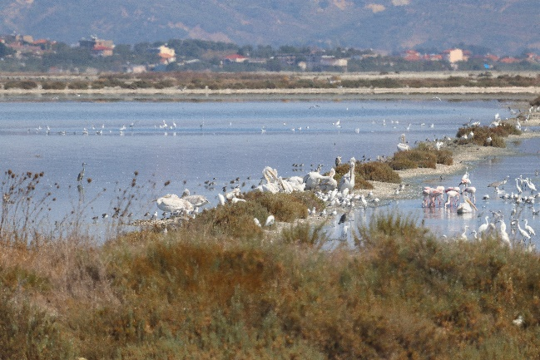
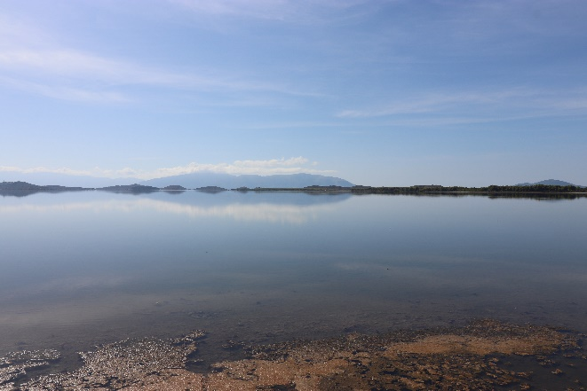
Still waters of the lagoon looking south The Salinas to the north
Almost immediately from the roadway we began to pick out small groups and individual birds. Avocet (Recurvirostra avosetta), Black Tailed Godwit (Limosa limosa), Black Winged Stilt (Himantopus himantopus), Dunlin (Calidris alpina), Greenshank (Tringa nebularia), Kentish Plover (Charadrius alexandrinus), Marsh Sandpiper (Tringa stagnatilis), Redshank (Tringa tetanus), Ringed Plover (Charadrius hiaticula), Ruff (Philomachus pugnax). There were groups of Slender - billed Gull (Larus genei), several Yellow – legged Gulls (Larus michahellis, Black-Headed Gull (Larus ridibundus) and Herring Gull (Larus argentatus)

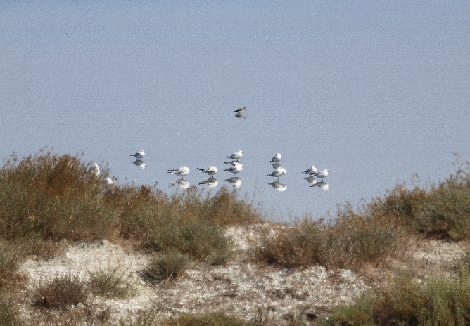
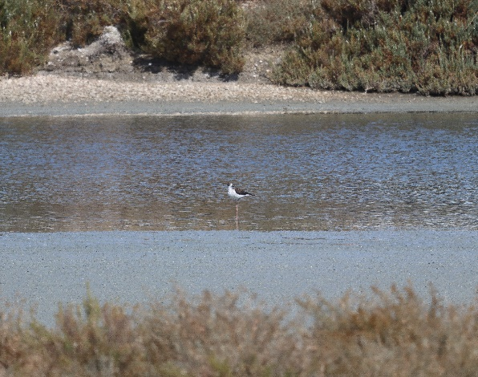
Black winged Stilt Slender billed Gull

While scoping some of these birds from one of the towers our attention was caught by the extravagant antics of two Caspian Terns (Sterna caspia) feeding on the lagoon. These large Terns provided us with a good (though distant) display for a few minutes before dropping out of sight onto a sandbar. Very different to the Arctic and Little Terns I’ve watched on Northumberland’s Long Nanny.
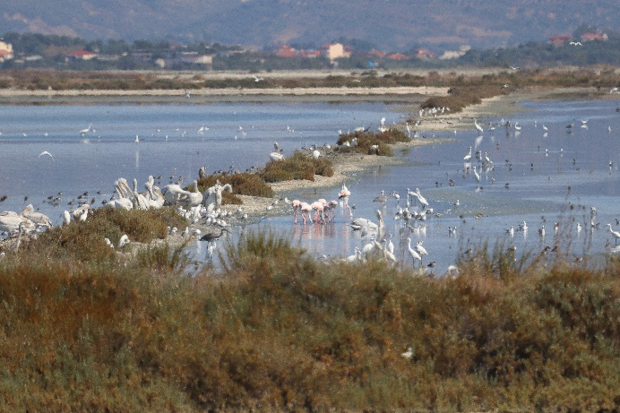
As we moved further along the roadway, we began to see large, mixed groups of birds around the embankments separating the pools of the salinas. In the group pictured (right) we identified Dalmatian Pelican, Little Egret (Egretta garzetta), Great White Egret (Egretta alba), Greater Flamingo (Phoenicopterus roseus) Slender billed Gull, Grey Heron (Ardea cinereal), Curlew (Numenius arquata), Greenshank and Redshank.
We parked the car and entered the salinas on foot, soon to be challenged by an employee of the salt producers asking what we were doing and saying we needed permission to be there. After Mirjan explained who he was and that he and colleagues involved in conservation work already had permission he left us to continue through the centre of the salinas. We spotted a group of waders way ahead of us and identified Little Ringed Plover (Charadrius dubius). Mirjan was certain there was something else in the group, but we needed to get closer, even with the scope. The group took to the wing two or three times before we got close enough for a better view through the scope and Mirjan was able to call three Little Stint (Calidris minuta). One more attempt and we just got close enough for a rather fuzzy record shot.
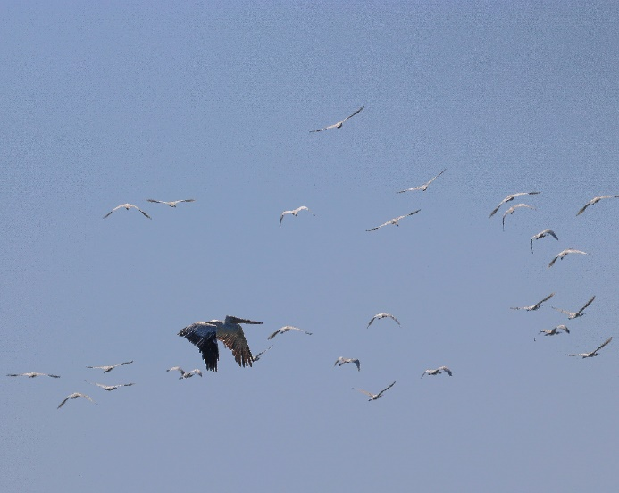
As we turned along a path on a raised embankment back towards the lagoon, we could see ahead in the distance a large group of birds, similar to the picture on the previous page. We knew they would take to the wing as we approached but Mirjan was confident that they would settle ok when we had passed. This was the embankment where we had seen Spoonbills (Platalea leucorodia), from the roadway and it wasn’t long before the sky in front of us was a wheeling mass of white (with a touch of grey and pink)
Spoonbills (and Dalmatian Pelican)
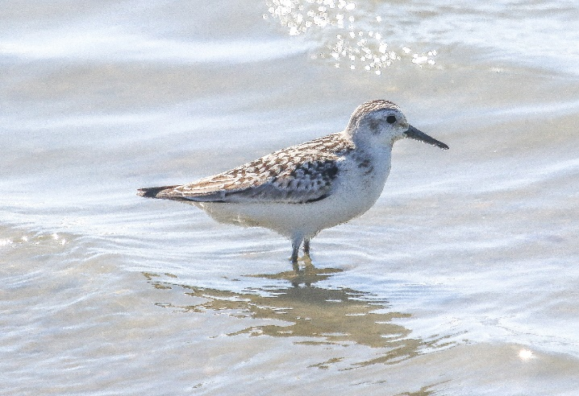
As we walked along, the whole embankment was empty apart from three small birds making their way towards us along the water’s edge. Sanderling (Calidris alba) is a species I see regularly along my stretch of the Northumberland coastline although I have to say I don’t usually get so close. These three didn’t seem to have much fear though and Mirjan was happier than me as they are only seen infrequently as passage birds in Albania. Sanderling

I spotted a dead Dalmatian Pelican on the side of the embankment. These really are big birds! Mirjan photographed and recorded this suggesting that it probably died of disease as even the largest predator in the area, the Golden Jackal (Canus aureus), would not be able to bring down a bird this size.
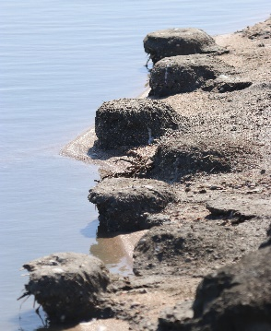
As we walked Mirjan pointed out the Flamingo nest platforms to the side of the embankment. In 2018 the Greater Flamingo
returned to the Narta lagoon for the first time in 21 years. Like other species they have returned to Albania after the hunting moratorium was introduced in 2014 and are now permanent residents at Narta where up to 6000 have been counted.

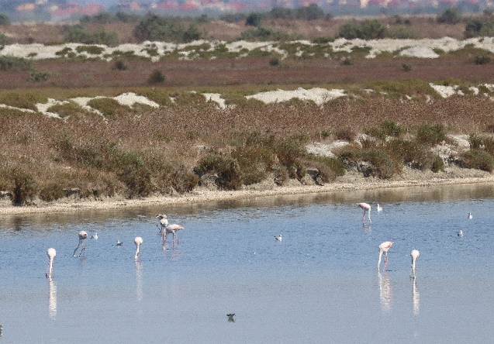
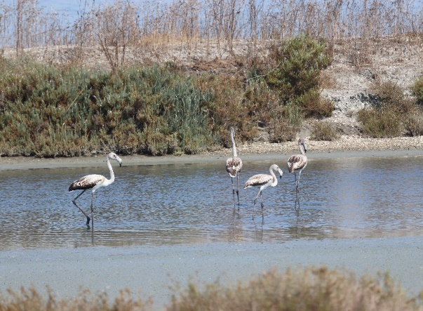

Greater Flamingo on the salinas Juvenile Greater Flamingo

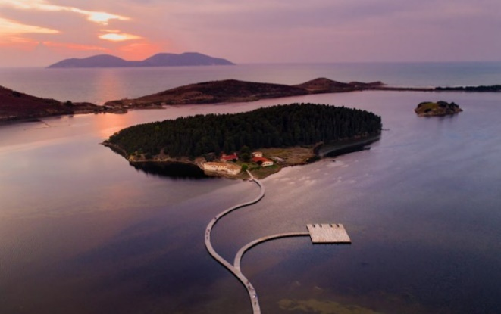
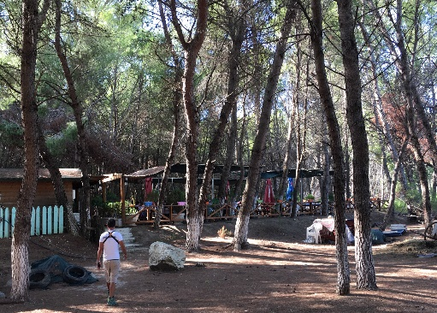
After a good couple of hours in the blazing sun we decided it was time for lunch, not to mention shade, before visiting the southern edge of the main lagoon. A restaurant in the forest would be ideal and Mirjan knew just the place. I have no idea which (two) species of local fish I was eating but they were delicious. The visit to the south of the lagoon was really to see the beautiful Byzantine monastery of Zvërnec situated on an island in the lagoon. The monastery was constructed in the 12th and 13th centuries and is reached by a lovely wooden walkway over the lagoon.
As we walked back to the car park there was
sudden action right above our heads as a
Sparrowhawk (Accipiter nisus) was trying to
escape a mob of about ten Hooded Crows, not the last raptor we’d see being mobbed.
Source: intoalbania

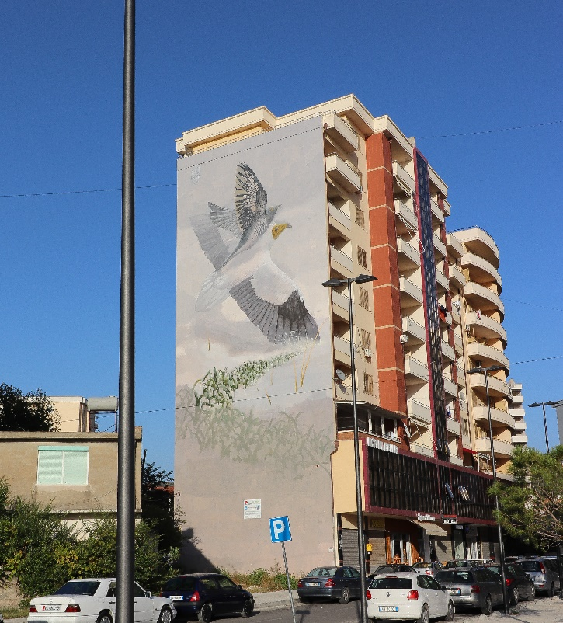
Birding finished for the day we would now drive on to the Adriatic resort town of Vlorë. I had visited Vlorë in 1992 and just remembered a very grey and bland place…and that there was a submarine base there. Now I don’t suppose any of us are fans of high-rises, but I have to say this is now a very pleasant resort. A wide pedestrianised promenade, grassed, tree lined with a lovely beach, runs for quite a distance. Hotels and restaurants are set well back so don’t spoil the ambience. As we drove through Mirjan stopped the car to show me a giant mural on the side of an apartment block, in full view of the main road.
The mural was painted as part of the
programme to protect the Egyptian
Vulture (Neophron percnopterus) –
known here as the Cuckoo Horse. Why? People would hear their first Cuckoos (Cuculus canorus) of the spring at the same time they would see the Egyptian Vulture reappear from its migration to sub Saharan Africa. They knew both birds went on a long migration but thought that, while the vulture is a big powerful bird capable of such a journey, the Cuckoo is not. So, it was thought that the
Cuckoo would hitch a ride! Hence the ‘Cuckoo Horse’. The mural shows the myth in action.
Mirjan and colleagues with the conservation NGO ‘Protection and Preservation of the National Environment in Albania’ (PPNEA) have been involved in a project since 2012 trying to protect this species which is critically endangered in Albania. The country was once home to three species of vulture but now only the Egyptian Vulture survives. This year just 5 breeding pairs and 4 individuals were recorded. Two fledglings were known to have made it to migration. Poisoning is a huge problem as farmers and shepherds leave out baited carcasses to attract the predators that take their livestock but PPNEA are working very closely with locals and have even persuaded some to create protected feeding stations. My own experience from this visit is that some farmers are genuinely pleased to see visitors come to see the birds, just as Mirjan and his colleagues have been promising. Amidst a general apathy towards birdlife PPNEA continue to develop educational work with the general public and especially young people.
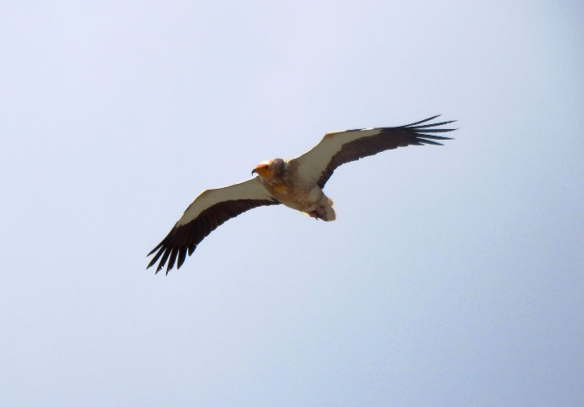
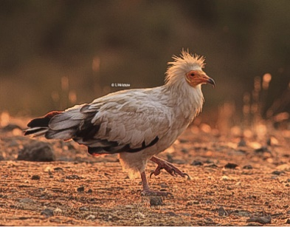

Source: PPNEA (Mirjan Topi) Source: PPNEA (I. Hristov)

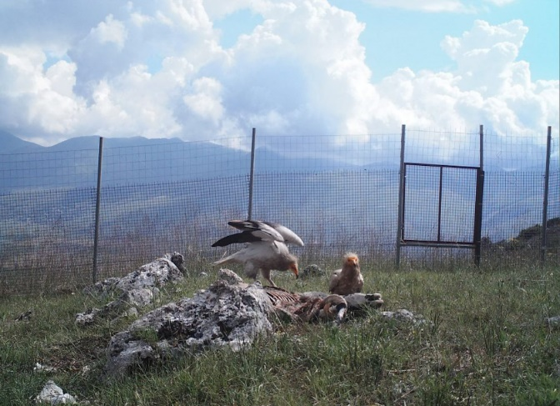

Meal at the feeding station
Source: PPNEA

Anyway, following the almost complete lack of sleep the night before, the journey and the day out in the sun, I was tired. So, it was an early night for me. I was happy though to have seen some beautiful scenery, some beautiful birds including 12 ‘firsts’ for this new birder and to have learnt about the Cuckoo Horse. The following day we would set off for the southern mountains hoping to see, amongst other species of course, the famous Cuckoo Horse. I already knew that the chances were that the birds had already set off on that long migration, but I was relaxed about this as my visit to Albania had been organised as a holiday and the birdwatching trip was really an afterthought. I knew that over the next two days I would still see amazing landscapes, the city of Gjirokaster and other bird species. I was already having a great time and I already knew that I would be back.
The southern mountains and Gjirokaster
We set off in the direction of Gjirokaster at 8.30am with a planned stop for lunch in the town of Tepelenë in the Vjosa River valley. On the drive we spotted Marsh Harriers and I had my first sighting of Lesser Kestrel (Falco naumanni) which was to be a star performer later in the day. Before reaching Tepelenë we would stop on the Vjosa River in an area where Mirjan thought we might see Blue Rock Thrush (Monticola solitarius) and Rock Nuthatch (Sitta neumayer), two species I had asked him about. Immediately after leaving the main road we stopped because of activity in the field and hedgerow to our left and observed Winchat (Saxicola rubetra), Grey Wagtail (Motacilla cinerea) and Spotted Flycatcher (Muscicapa striata). A passing farmer recognised Mirjan from his field work visits and asked if ‘his English visitor’ would like some fresh grapes from one of the baskets astride his donkey. Mirjan had already told me about the hospitality of the locals out in the rural areas although after a few visits I was already well aware of the warm welcome visitors receive in Albania. We then left the road a little further along and entered a wooded area with numerous dead trees. Mirjan had observed woodpeckers here before and, as we were passing, thought we’d try our luck. Albania is home to 9 species of woodpecker but on this short detour we struck out.
We reached a gorge on the Vjosa River and after parking on a bridge and watching Ravens (Corvus corax), Buzzard (Buteo buteo) and Kestrel (Falco tinnunculus) in and above the gorge we set off on a short walk along a very rough path up the side of the valley. (on left of the picture below)
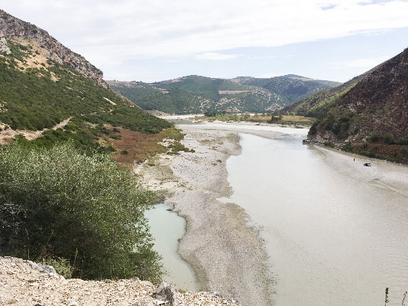
All was quiet as we walked. Still only Ravens and Buzzards were in view. Mirjan was getting worried that we may strike out again, but we decided to walk on further. Then we heard two different birds calling and Mirjan played the call of the Blue Rock Thrush on his phone. Sure enough we caught sight of a female on a rock a way above us. She flew off but returned, along with a male although he didn’t show himself so well. They were just about close enough for record shots although we had good views through the bins. As we watched another bird caught my eye perched in the top of a bush a little closer. We confirmed it as a Rock Nuthatch. Although a little far off it showed itself well for about the next 10 minutes until we decided it was time to move on. We were both well pleased that our two target species had showed up for us.

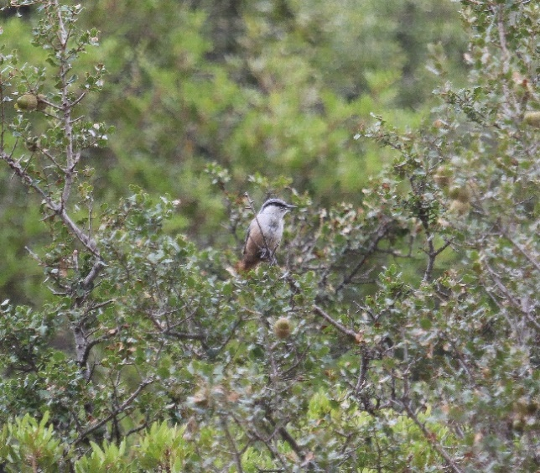
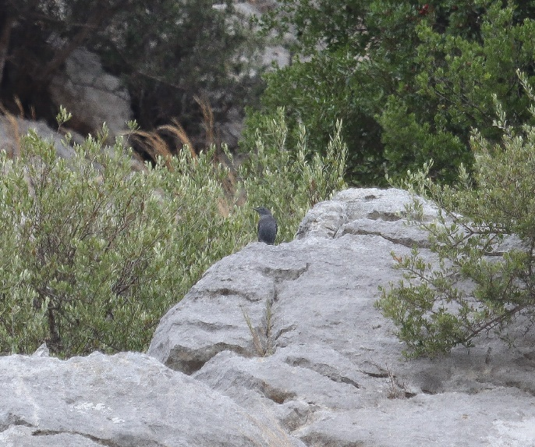
Blue Rock Thrush Rock Nuthatch
We then visited the first of three localities where Egyptian Vultures were known to have nested this year although the precise nest sites remain protected. Unfortunately this pair had already left.
Mirjan drove very carefully back down the rough mountain road towards the main road for Tepelenë. Part way down the car lurched and there was an almighty bang on the underside. A quick inspection showed an oil leak and some damage, evidenced by small shards of metal on a rock! Although driving even more carefully now the car was making some strange noises, and still leaking some oil. Back on the main road we stopped at a ‘service’ to see if there was a mechanic available. A young guy agreed to have a look and after assessing the damage disappeared into a ‘car graveyard’ at the back of the building and after a while emerged with a smile and a part for the damaged gearbox in his hand. It must have been a good 2-2 ½ hours before we were on our way again. The good thing was the price at less than 15 euros!
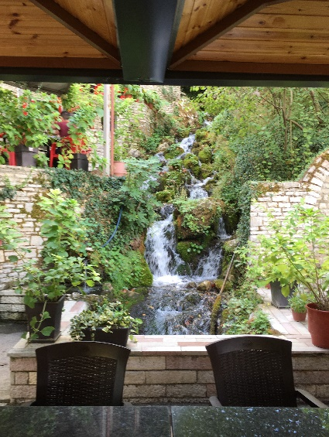
Mindful of three specific sites we still had to visit that day we were both ready for some sustenance. A stop at a restaurant in Tepelenë was just the job. Tepelenë, sitting in the beautiful Vjosa River valley, is famous for its spring water and, as you can see from the photograph left, the spring runs right through this restaurant. There is an Italian owned bottling plant further along the road but the locals, and us, filled our bottles for free at the fountains just in front of the restaurant.
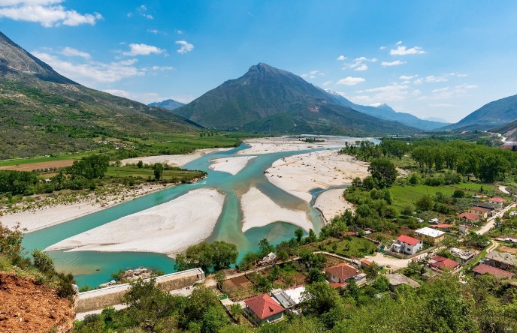
The town is also famous because Ali Pasha of Tepelenë, an Ottoman Albanian ruler was born in a village nearby. A plaque on the castle wall commemorates the occasion when Lord Byron stayed as a guest of Ali Pasha.

The Vjosa River valley at Tepelenë
(Source: www.thebalkanista.com)

Lunch finished, we were off to our second Egyptian Vulture site. As we carefully drove onto the farmland a Kingfisher (Alcedo atthis) flashed by. Goldfinches (Carduelis carduelis) chattered noisily in a tree near to where we stopped for our first scan and we almost stepped on a well camouflaged Hermann’s Tortoise (Testudo hermanni). It was nice to actually see one in the wild. Scanning of slopes and ridge from an open pasture revealed nothing. Mirjan thought it best to move on quickly as we had one more vulture site to go and we had an ‘appointment’ at 6.30 pm!
As we left the main road to head towards the third site we spotted a small flock of European Bee-eaters (Merops apiaster) on telephone wires and the shrubs at a field margin. The previous day we had passed the site of a colony in a bankside not 10 feet away from the road. There was no sign of these colourful birds and Mirjan thought they had probably all left on migration. We stopped at what we thought was a comfortable distance to view through the bins thinking we might then try to get closer for some photographs. Sat in the car we both raised our bins just as a monster digger came roaring past and scared the living daylights out of every creature around (including us!). We could see that the Bee-eaters had taken flight but then settled again back in the direction we had come. Mirjan reversed, again to a comfortable distance. We had a good view of 5 birds perched on the telephone wires, but they didn’t stay long. These stragglers had been well and truly spooked.
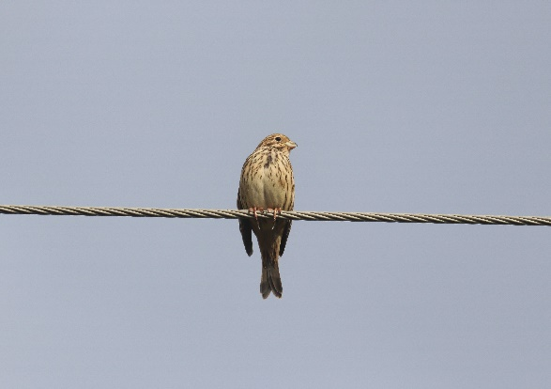
Then on the same stretch, on the same wires, we got views of a juvenile Red-Backed Shrike (Lanius collurio) which wouldn’t settle close enough for more than a fuzzy record shot and good views of Corn Bunting (Miliaria calandra) when a handful appeared in quick succession. Along the way we also caught sight of several Lesser Kestrels which were certainly plentiful in this area.
Corn Bunting
Collared Doves (Streptopelia decaocto) also made regular appearances, as they had in the grounds of my Durres base since my arrival.
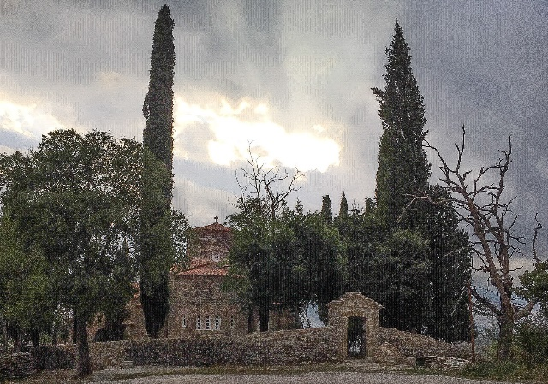
We had to press on, however, to our final vulture sight of the day. Up the mountainside through an ethnic Greek village and along a road which was being reconstructed as we went. We were now in the beautiful Drino Valley in a region where there is a large ethnic Greek community. The regional capital Gjirokaster is only 19 miles from the Greek border.

Orthodox church on mountain road

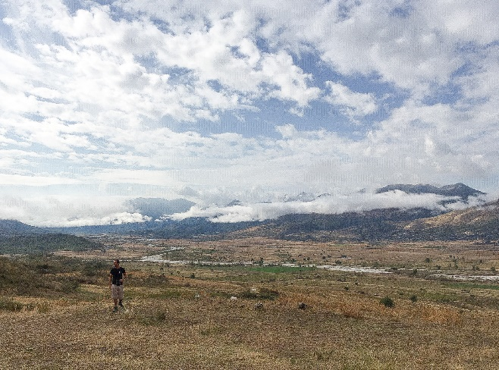
As we drove higher I thought one of three enormous sheep dogs was actually going to try biting the car. Nothing like the popular collies we know, these fearless canines are very protective of livestock and owners. I was pleased we were going up and the shepherd and his animals were on the descent. Unfortunately, once again, there was no sign of Egyptian Vultures. We saw Buzzard and Raven again and listened to Rock Partridge
(Alectoris graeca) calling as the light began to fade. The Drino Valley (and Mirjan)
Time to move on for our 6.30 appointment.

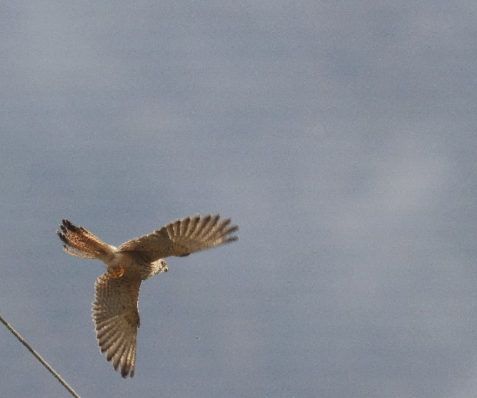
We headed for the village of Jorgacat not far from Gjirokaster. Mirjan had told me that here was the largest Lesser Kestrel roosting site, probably in the world. Mirjan and his colleagues had counted up to 2000 birds before but visiting ornithologists had counted up to 6000, and here we were on the main road into the village, one tree right outside the police station and three more on the other side of the road. Four trees and up to 6000 birds! The Drino Valley appears to be a major feeding site for these birds pre-migration. Of course, there weren’t so many birds when I visited. As I’ve already said my trip was slightly mistimed. We had seen numerous Lesser Kestrels during the last two days but most of the birds had already left on migration. Lesser Kestrel
For ‘scientific purposes’ Mirjan clapped his hands and 50-70 birds cleared the main tree swirling around for maybe 20 seconds before settling again. A police officer came out to see what we were up to. He clearly felt some responsibility towards these small falcons and told us how, at times, the station and surrounding trees would be covered in them.
By now darkness had fallen and it was time to leave the birds in peace and head for our own roost, in another ethnic Greek village along the road. We arrived at about 7.00pm and it had started to rain. By 9.00pm the storm had started and lasted right through the night. I have never heard thunder or seen lightening like it. Apparently the storm raged over most of the country. So, another disturbed night but my consolation had been a spotless, very comfortable hotel with pleasant staff and tasty Greek food for about 15 euros b&b.
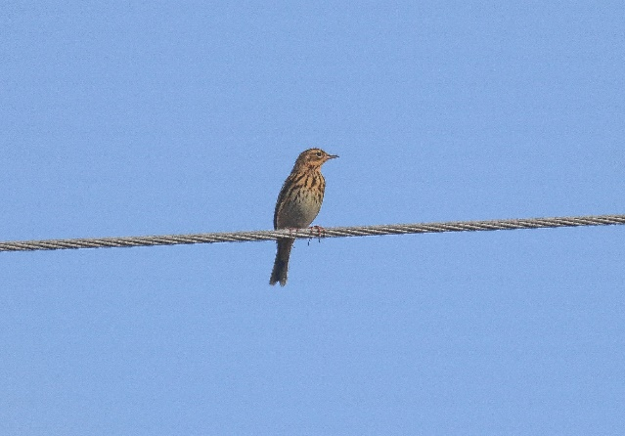
Time was allocated next day for non-birding. A visit to Gjirokaster with time to actually see the place. I had only waited 27 years to come back. Mirjan, however, wasn’t giving up on those Egyptian Vultures completely so we would re-visit site two (on the road back towards the coast) and site three (a short drive from our hotel) before leaving the region, just in case! As we pulled off the main drag and headed towards the mountains birds began to appear along the same stretch of wire and hedgerow. Lesser Kestrels were up and about and we stopped to take pictures of a more cooperative Common Buzzard and as we did two Tree Pipits (Anthus trivialis) appeared and settled on the wire. (this was a productive stretch of telephone wire!) Tree Pipit

Mirjans attention was then caught by a small group of warblers in a shrub slightly behind us. He called a Bonelli’s Warbler (Phylloscopus bonelli) and as he described the species even this novice was able to confirm the yellowish rump and yellow patch on the wings. Then would you believe it, as we tried to get a better view and maybe even a record shot for me, just like the day before everything was disturbed by another vehicle. We drove along this road four times in two days and on the two occasions another vehicle passed we were thwarted when watching species of interest. This time we had to move to allow the other vehicle past and by then the birds had moved. Mirjan was then onto another group, possibly the same birds, on the other side of the road and this time called a Subalpine Warbler (Sylvia cantillans). As he pointed it out to me it was away in a flash but I was happy to trust him on this one.
It was then time to get up that mountain.
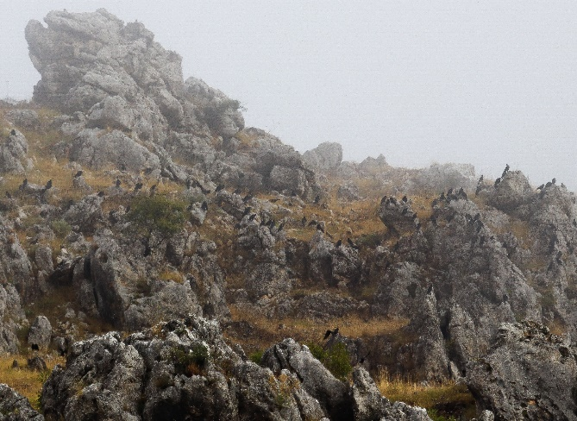
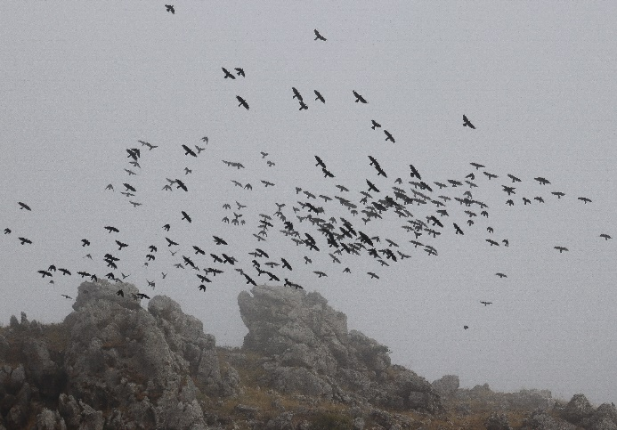
It was very quiet and dull near the vulture site. The only sound was the clanging of the bells around the necks of the sheep and goats. There was no sign of the vultures so we decided to head off into Gjirokaster. As we turned to leave we both then noticed dark shapes lined up like sentinels on the rocks way above us as the low cloud shifted a little. Then they were up, wheeling, shooting skywards and diving. 200 plus Alpine Chough (Pyrrhocorax graculus). Another first for me and a nice little compensation for the absent vultures.

‘Sentinels’ Alpine Chough in flight

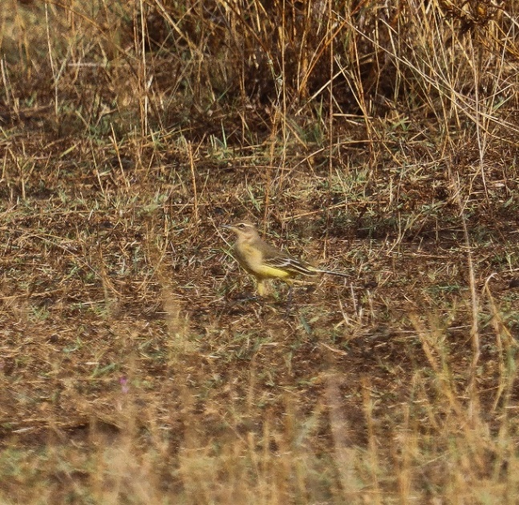
On our descent we saw 4-6 Jays (Garrulus glandarius) moving noisily between trees on our right and more Hooded Crows squabbling on the slope to our left. As we drove back along the road towards the main drag we saw numbers of Northern Wheatear, Grey Wagtail and a group of about a dozen Yellow Wagtail (Motacilla flava flavissima) so well camouflaged in a field of dry vegetation.
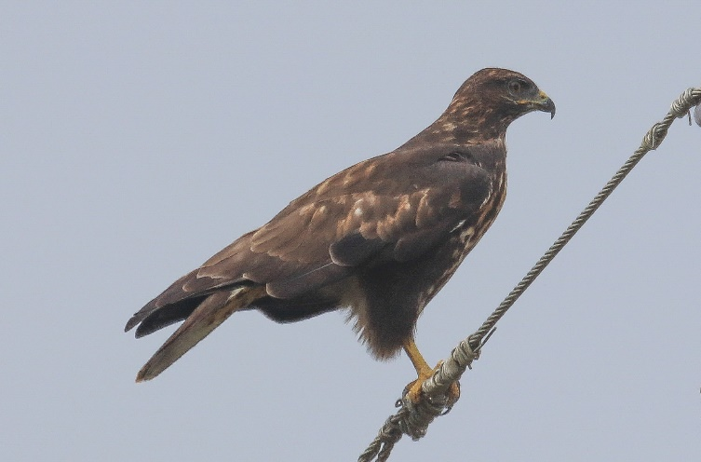

Yellow Wagtail

Common Buzzard

Gjirokaster

I had visited Gjirokaster in 1992 but that really was a flying visit due to work. This time I would have the opportunity to visit the old town and castle on the mountainside overlooking the beautiful Drino Valley. The old town is a UNESCO World Heritage site described as ‘a rare example of a well- preserved Ottoman town’.
Gjirokaster is known as ‘the city of stone’. A distinctive feature is the silvery limestone which gives the town its character. The stone is quarried nearby and is used in the construction of buildings, roofs and street surfaces.
The Ottoman Empire expanded into Europe in the late 13th century and by 1420 it is believed that Gjirokaster and the entire Drino Valley had fallen under Ottoman control.

During King Zog’s reign (1928-1939) the town established itself as one of the most important cultural and economic centres in the country.

Gjirokaster was declared a ‘Museum City’ by the communist regime in 1961 in an effort to conserve the unique cultural heritage of the town. As well as more specialist craftsmen a large conscripted workforce, consisting mainly of young people known as ‘Volunteer Youth Brigades’, was assembled to maintain the old town.

The Castle

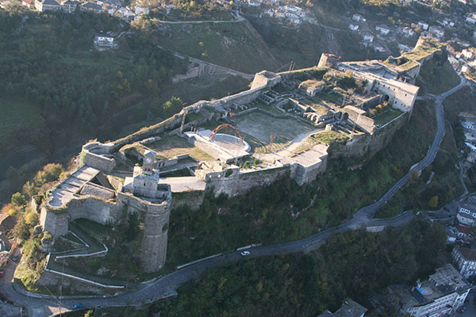
The castle sits on a rocky bluff with the town stretching out around it. It offers spectacular views of the Drino Valley and surrounding mountains. The first major fortifications were built in the 12th and 13th centuries and, after the Ottoman conquest, extensive improvements were made around 1490. From 1811 the Ottoman governor, Ali Pasha of Tepelenë, added numerous elements including a clock tower, an aqueduct to bring
Source: www.gjirokastra.org water over 10km from the surrounding
mountains and an extension to completely fortify the entire bluff.
It was later known for the large prison constructed in the castle during the reign of King Zog.
Some of the castle is now in poor repair or just empty, but it houses the Bektashi Tomb containing the remains of two 17th century Bektashi Babas (spiritual guides), an artillery gallery with artillery and a tank captured from Italian and German forces in world war 2, the National Armaments Museum and ….the remains of a United States Air Force T33 Shooting Star plane forced to land at Tirana airport in 1957 due to technical problems (you can’t beat a bit of cold war propaganda!!). There is also a stage in the grounds which is used for the Albanian National Folk Festival and local music and dance events.

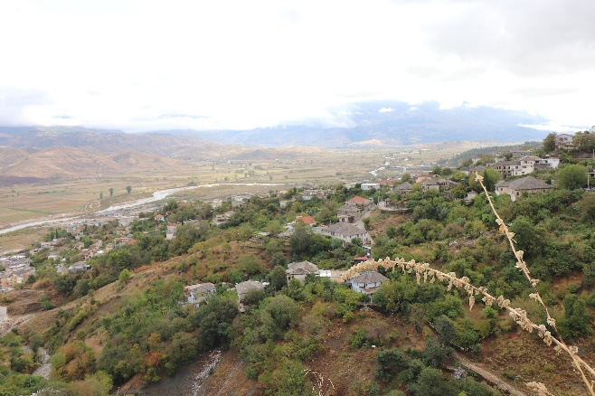
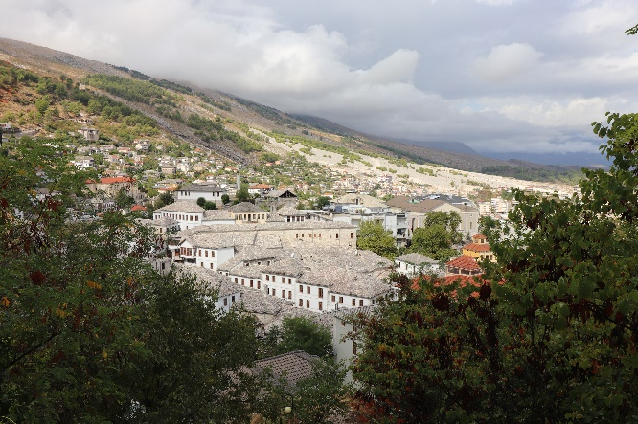
Views from the castle over the town and the Drino Valley

The Bazaar

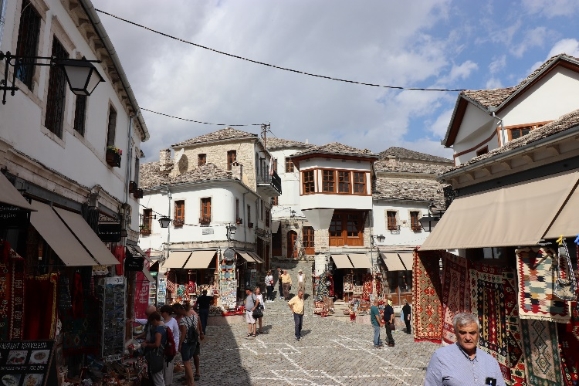
Until the mid-20th century Gjirokaster was an important market centre for agricultural products from the region, leatherworking and woodworking. The combination of administrative positions and vast feudal landholdings provided the basis for the wealth of the town.
By the 1580’s the town had more than 400 dwellings and in the 17th century the Ottoman governor laid out a new commercial quarter with all roads coming together at the ‘neck’ of the bazaar. This first planned town centre was almost completely destroyed by fire and rebuilt in the 1750’s. Another fire in 1912 resulted in further reconstruction. Nowadays the area is the heart of the touristic interest with many shops, artisan activities, bars and restaurants.

Tower houses

While the architecture of the historic buildings in Gjirokaster is clearly influenced by Ottoman traditions the old town is itself a product of many elements. Topography has done much to determine the location and layout of the town which grew up on the steep slopes below the castle. The availability of natural stone for building blocks and large limestone roof slates helped to create the distinctive look of the town.
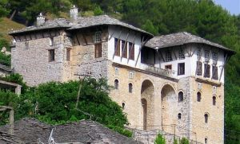
Gjirokaster was an important administrative centre in the 19th century populated by landowners with the means to build the grand fortified tower houses known as kullë. There are over 500 of these historic buildings in the town. The design of these houses is a function of Albanian life at that time. A well defended residence was necessary as disagreements between Albanian clans often lead to violent feuds. In addition there were a number of rebellions against the ‘Sublime Porte’ in Istanbul. It was also important to have a secure structure to house livestock in the winter and to have a cool water store during the long dry months of summer. The stone lower sections of the tower houses were both defendable fortresses and serviceable storehouses. The social spaces in the upper levels of the house reflect the hospitable nature of the Gjirokaster people as well as their cultural need to display the high status of the occupants Source: www.gjirokastra.org
through opulent interiors.
The ‘Zekate House’, shown above right, is the best surviving example of an Ottoman tower house in Gjirokaster.
(All factual information about Gjirokaster courtesy of www.gjirokastra.org)

After a few pleasant hours wandering around this lovely town it was time for lunch. I had mentioned to Mirjan that when I came to Gjirokaster in 1992 my two Albanian minders insisted on having a photograph taken with me on the spot where the communist leaders statue had stood (this town was the birthplace of Enver Hoxha). After the revolution of spring 1991 the locals had toppled the statue off its platform and smashed it to pieces. So, this visit we just had to have lunch in a restaurant now occupying part of that very site.

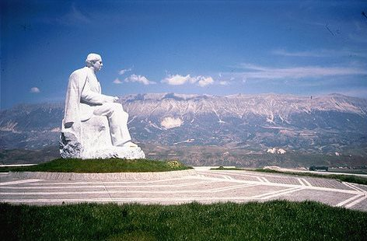
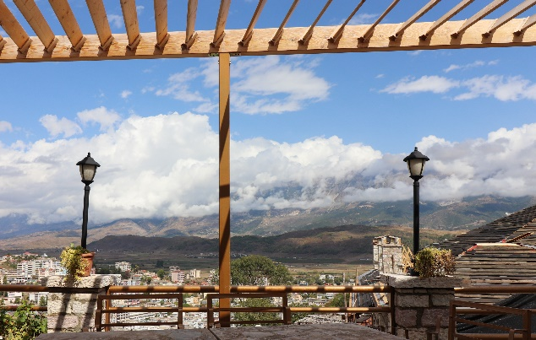

Source: www.gjirokastra.org

Although the last few hours had been non-birding, even as we walked back to the car which was parked just below the castle Mirjan pointed out a large tree which was well known as a roosting site for the Lesser Kestrel….in the heart of the town.
We now had just one more call to make. We would try Egyptian Vulture site number two again just to be sure we hadn’t missed anything. No luck, but some compensation again when the national bird of Albania, the Golden Eagle (Aquila chrysaetos) came soaring along in front of the ridge. We watched until it was mobbed by Ravens and brought to ground. Once the air was clear this magnificent bird took off again giving us good views through bins and scope. This was to be the very last ‘spot’ of my short birding trip in Albania and I like to think the national bird showed itself last just to say “thank you for coming, see you again”.

